**Lab 12 : Trapezoidal Rule & Gaussian Quadrature Formula**

**Objectives**

The purpose of this lab is to get familiar with Trapezoidal Rule.

**Tools/Software Requirement**

Matlab R2016a

**Example**

## The Trapezoidal Rule

The idea of the trapezoidal rule is to approximate a general curve by trapezoids, like this. We illustrate with the problem of integrating sin(x) from 0 to pi. Of course, the true value of the integral is 2.

ezplot('sin(x)', [0, pi]), hold on

approx = zeros(1,7); %initialize vector of results

for j = 1:7

n = 2^j;

x = pi*(0:1/n:1);

plot(x, sin(x), 'r')

weights = [1, 2*ones(1,n-1), 1];

approx(j) = pi/(2*n)*sin(x)*weights';

end

disp('Using Trapezoidal Rule')

disp(' n Approximation')

for j = 1:7

disp(['n = ', num2str(2^j, '%d'), ' ', num2str(approx(j), '%1.10f')])

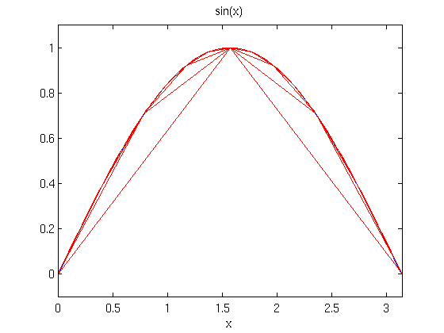

**Lab Task**

Use the **trapezoidal rule** and **Gaussian Quadrature** rule to numerically integrate:



From a = 0 to b = 2.

Also plot the values.

## Code for Trapezoidal Rule:

ezplot('0.2 + 2*x + 90*x.^2 -120*x.^3 + 25*x.^4', [0, pi]), hold on

approx = zeros(1,7); %initialize vector of results

for j = 1:7

n = 2^j;

x = 2*(0:1/n:1);

plot(x, 0.2 + 2*x + 90*x.^2 -120*x.^3 + 25*x.^4, 'r')

weights = [1, 2*ones(1,n-1), 1];

approx(j) = 2/(2*n)*(0.2 + 2*x + 90*x.^2 -120*x.^3 + 25*x.^4)*weights';

end

disp('Using Trapezoidal Rule')

disp(' n Approximation')

for j = 1:7

disp(['n = ', num2str(2^j, '%d'), ' ', num2str(approx(j), '%1.10f')])

end

## Output:

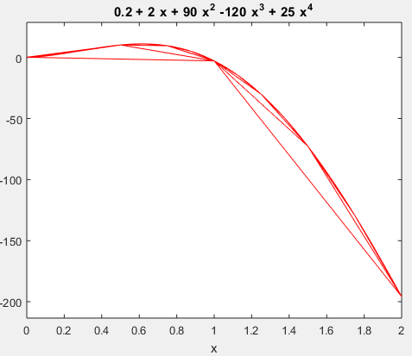

## Code for Gaussian Quadrature Rule:

t = [0 1 2 3 4 5 6 7 8 9 10];

v = zeros(1,11);

g = 9.8;

c_d = 0.25;

m = 68.1;

a = sqrt(g*c_d/m);

b = sqrt(g*m/c_d);

for i= 1:11

v(i) = b * tanh(a * t(i));

end

sum = 0;

h = t(2) - t(1);

for i = 1:10

sum = sum + ((h/2) *(v(i) + v(i+1)));

end

sum = vpa(sum,8);

fprintf('The distance calculated by Guassian Quadrate rule is: %.8f\n',sum)

## Output:

